University of Rwanda
CST Nyarugenge
Computer engineering
Mobile application for handheld device
Dart programming lab1 output

Part 1. Functions
Problem 1,2, and 3 outputs

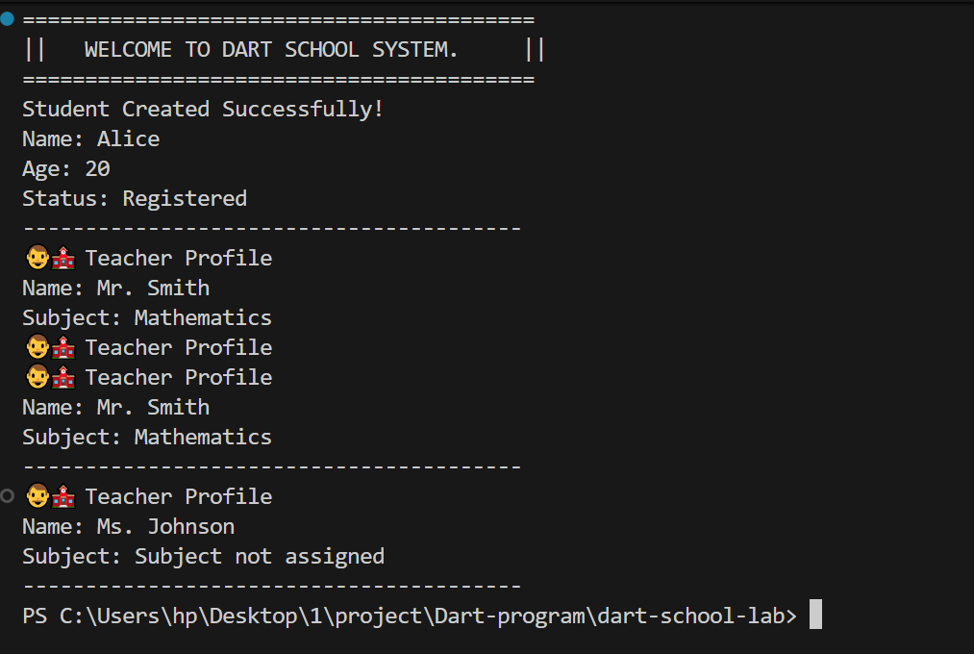

Part 2: Constructors and Classes

Problem 4 and 5 outputs



Part 3: Inheritance
Problem 6 and 7 outputs

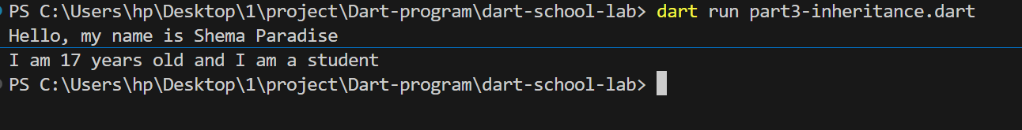

Part 4: Interfaces
Problem 8 and 9 outputs

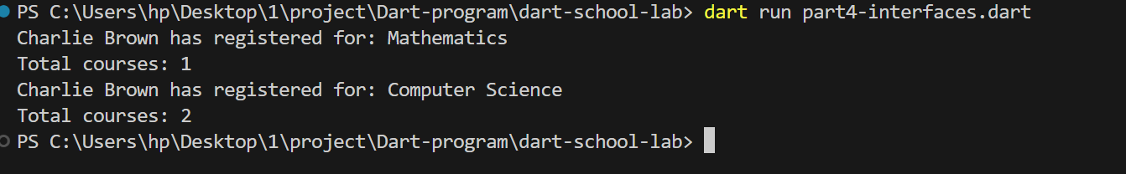

Part 5: Mixins
Problem 10 and 11

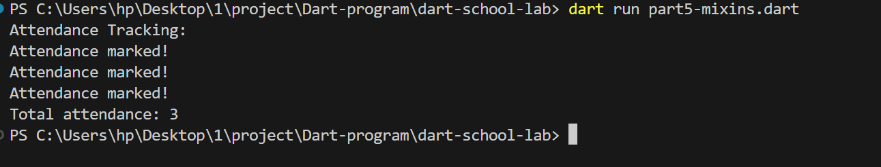

Part 6: Collections
Problem 12 and 13

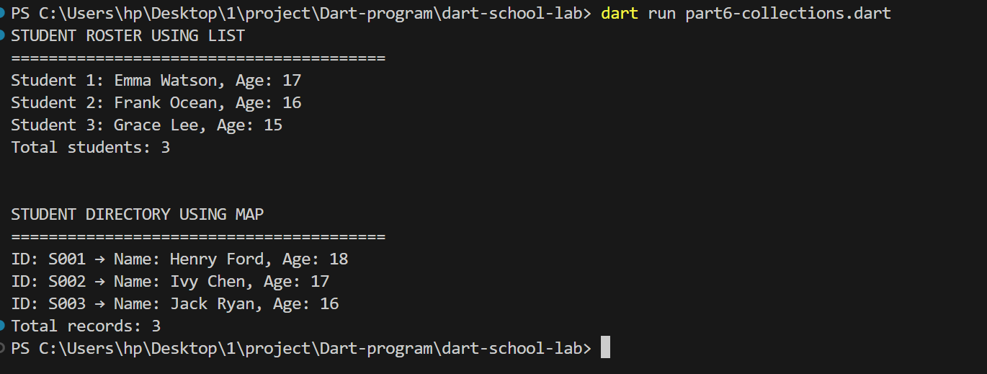

Part 7: Anonymous and Arrow Functions
Problem 14 and 15

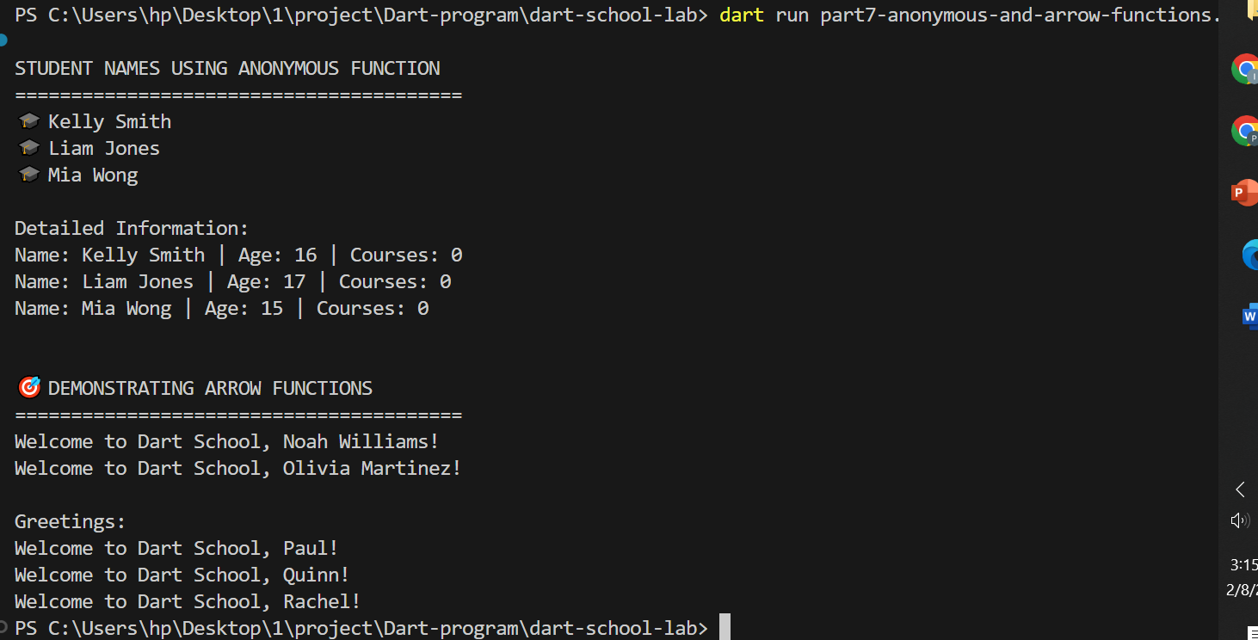

Part 8: Asynchronous Programming
Problem 16 and 17
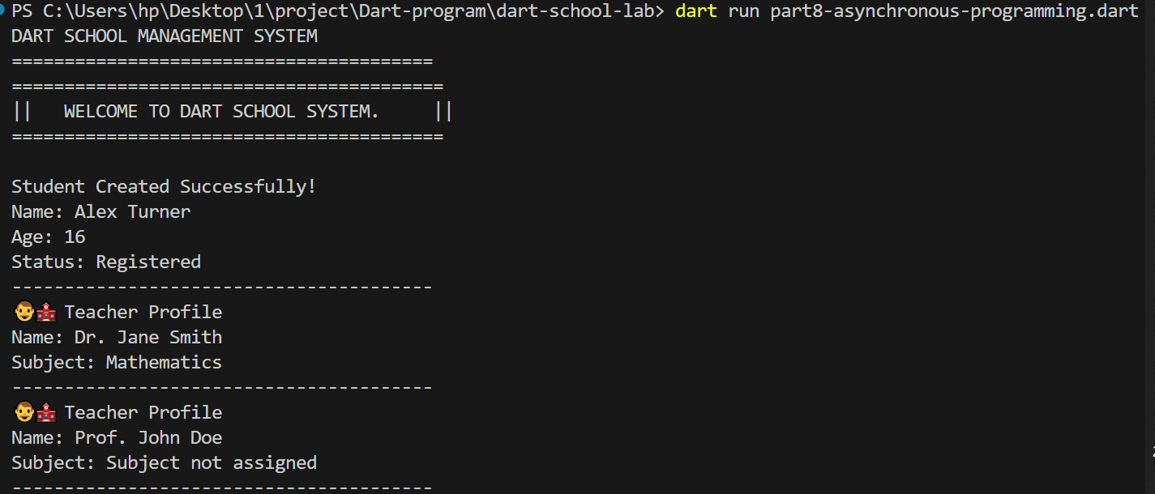
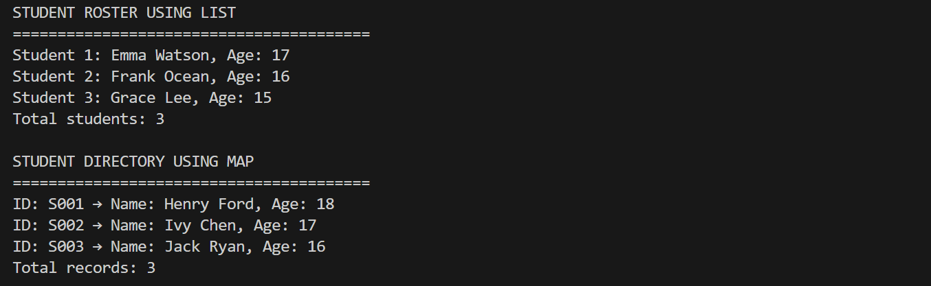


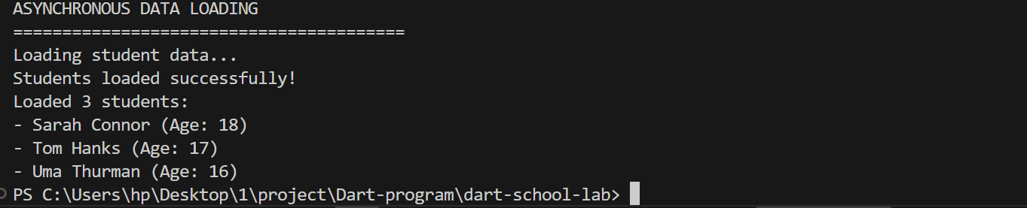

Part 9: Integration Challenge
Problem 19 and 20

